**Case Designer:**

**Case Types: before pega 7 also we have case types.  Case designer : is available from Pega 7**

**Case Designer: Contains Built-in Process flow ( It will create a WO in the run time). It will have stages.**

**Stage = Set of Multiple flows ( Collection of flows- Under Stage all flows are sub Flows)**

**Square Box: Process ( 1 Flow) - Here every flow is a sub flow**

**Step: 1 Flow Shape**

**Case Type-> Case Designer->Data Model(Optional)-> Add Work Flow(Life Cycle)-> Stages-> Process( Flows)-> Steps( Flow Shapes) -> View ( Section & Flowaction)**

**pyStartCase: is the starting Process flow**

**After we add case type, stages, processes, steps and Views It will create below rules.**

* **Class which belongs to and inherits from class group.**
* **Properties**
* **Sections**
* **Flow Actions**
* **Flows**
* **Case Type**

**Req:  Redesign Work flow to have stages & steps using case types:**

**Working with Case Type & Case Designer:**

**Add New Case Type from Cases Explorer:**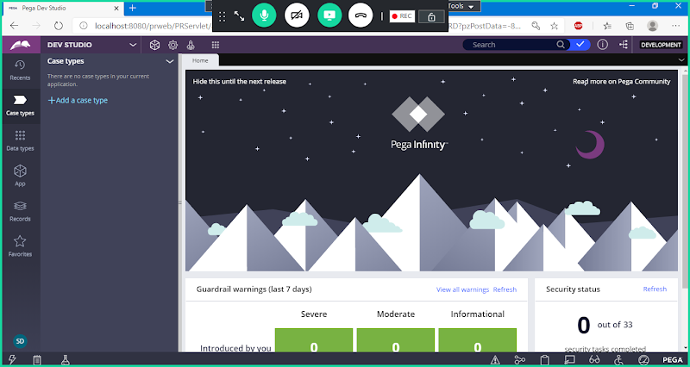

**Click on Add Case Type:**

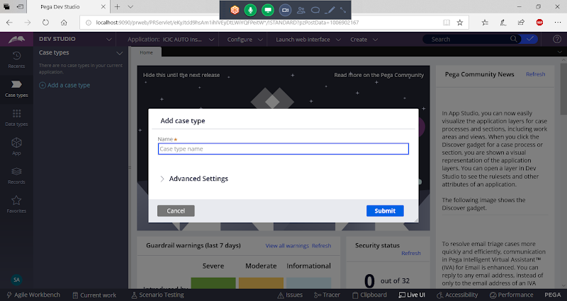

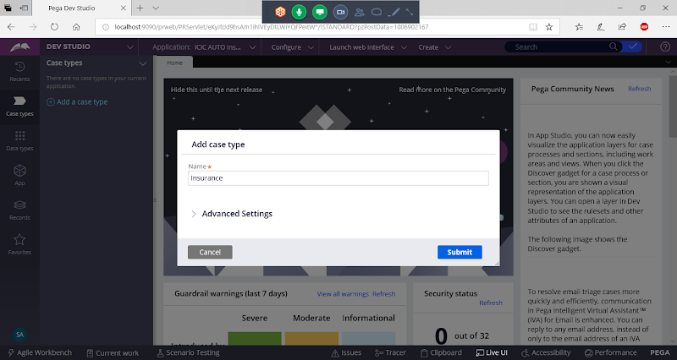

**Expand Advanced settings:**

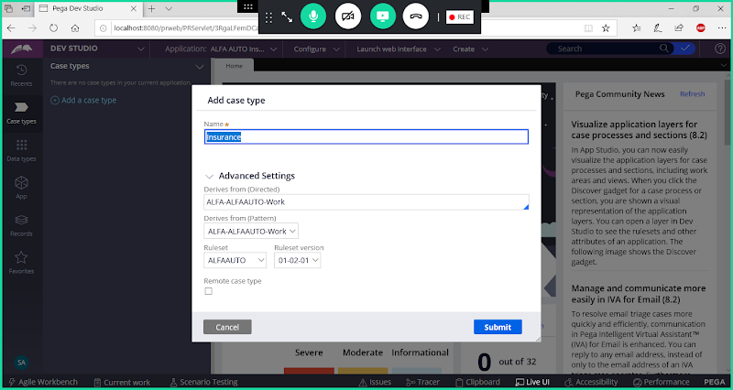

**Submit**

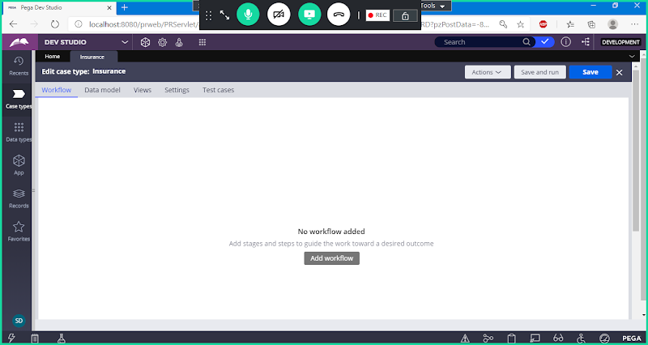

**Click on add Work Flow:**

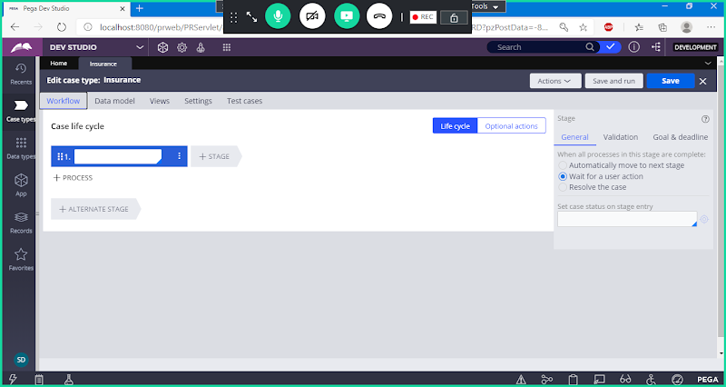

**Add Stages:**

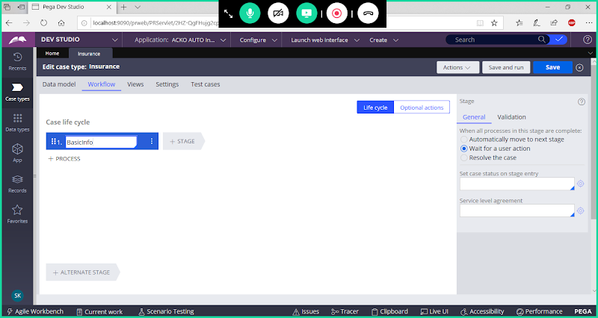

**Now Add Stage names:**

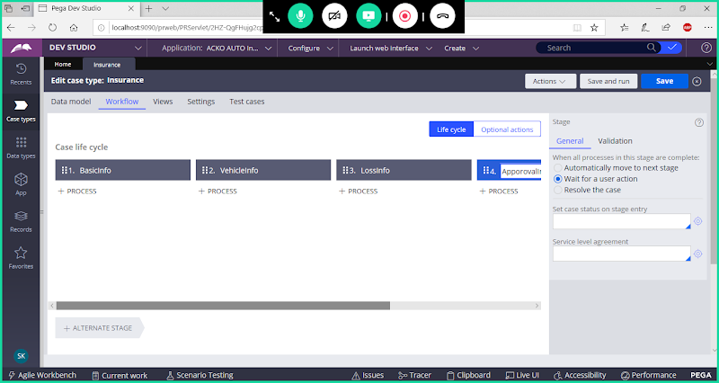

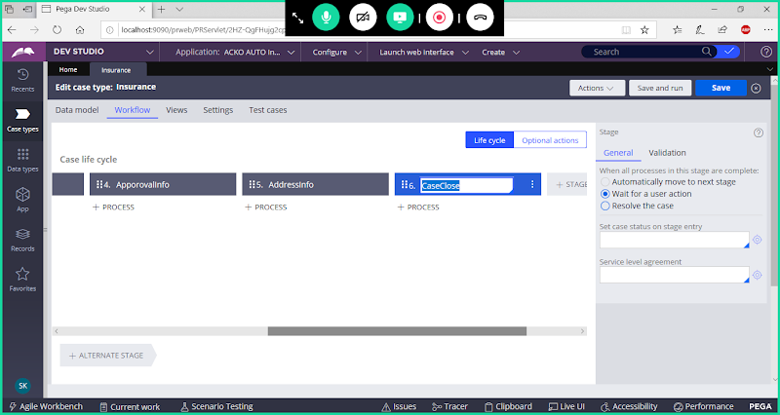

**For Case Close Stage :  Set the status as Resolved Completed:**

**First Click on radio button - Resolve the Case**

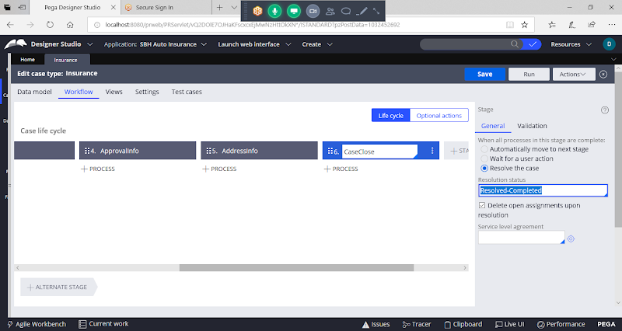

**Add Process under each stage:**

**Click on Add Process & Step Names**

**Under Basic Info Process-> Add Step-> Collect Info:**

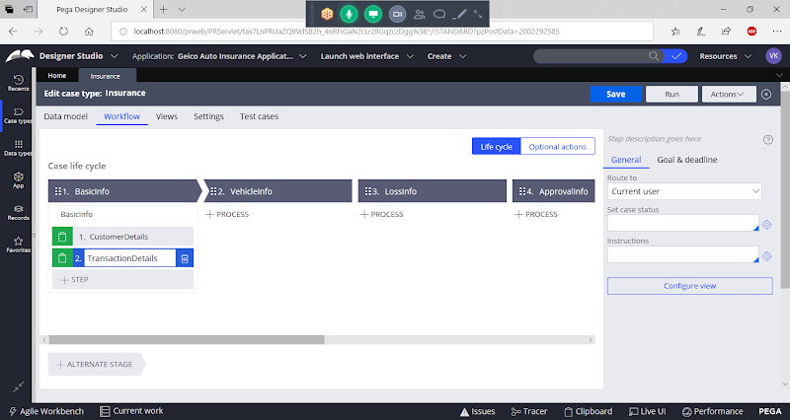

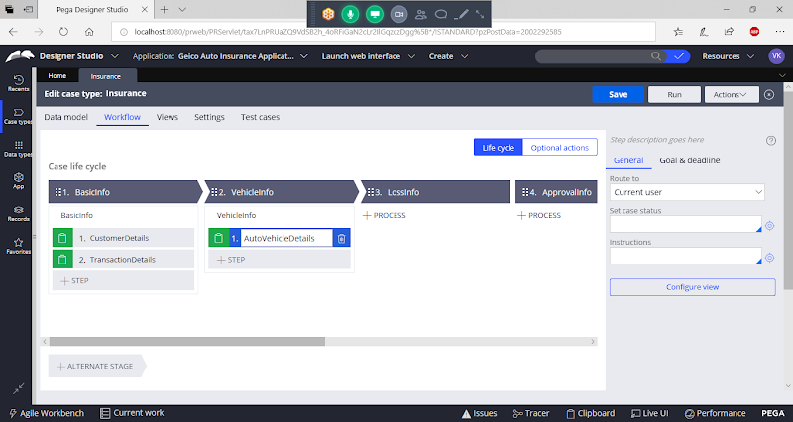

**Now Add Steps under Each Process:**

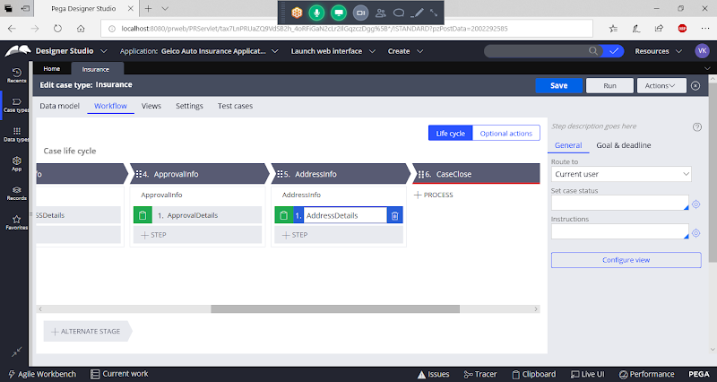

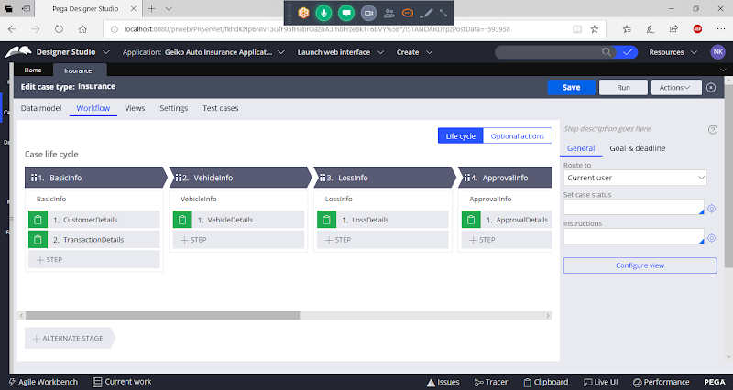

**Save Case Type**

**Configure View: User Interface**

**View :  Flowaction  -> Section**

**When we configure View it will create Section & Flowaction for each view**

**For Each step we have to configure the View:**

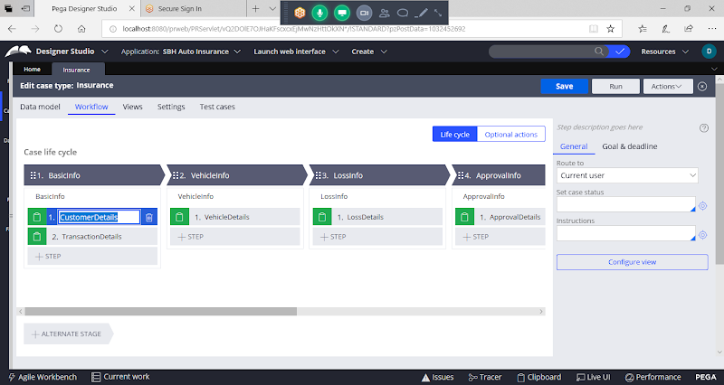

**Click on Step -> Click on Configure view:**

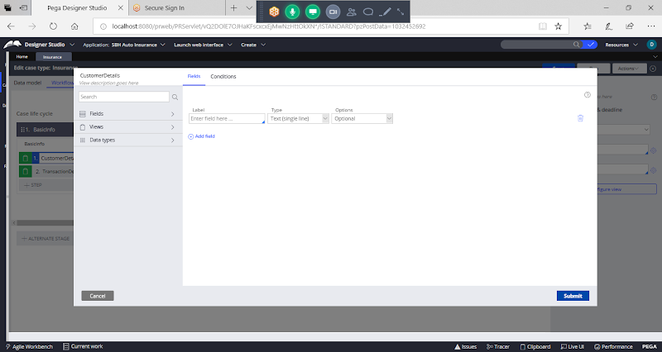

**Click on Submit:**

**Similarly configure view for remaining steps in the Life Cycle:**

**After Configuring View save the case:**

**===**

**Case Type Classes/Work Classes: Concrete - Belongs to Class group**

**For any Case Type: Starting Process is : pyStartCase**

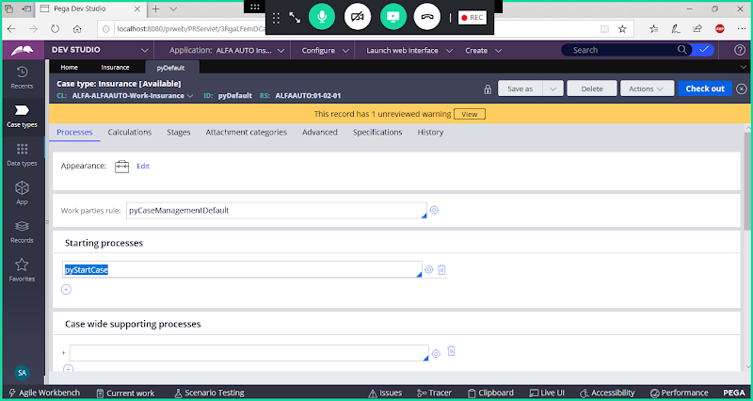

**---**

**With Drawn-> New & Perform Harness Rules:**

**Open New Harness Under Work Layer & Withdrawn the Rule:**

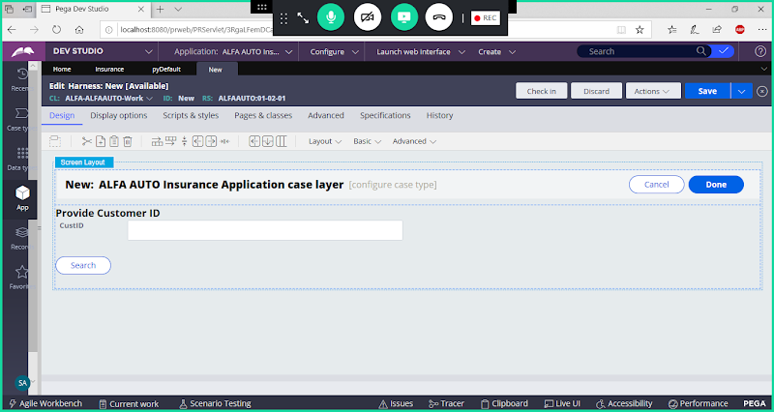

**Now Select WithDrawn**

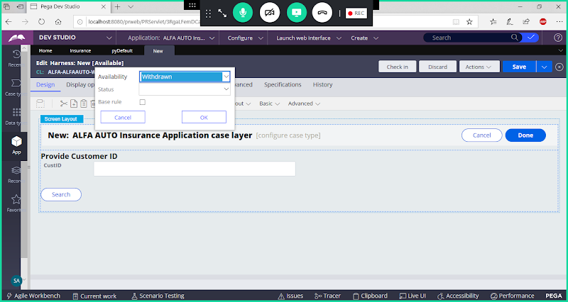

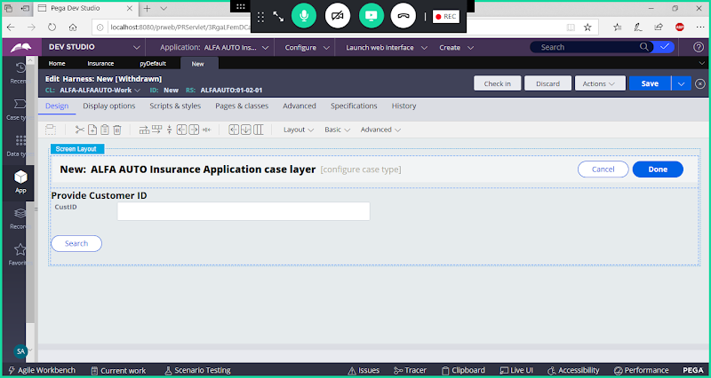

**Save & Check in**

**Open Perform Harness & Withdraw ( Open From Records Explorer-> UserInterface -> Harness)**

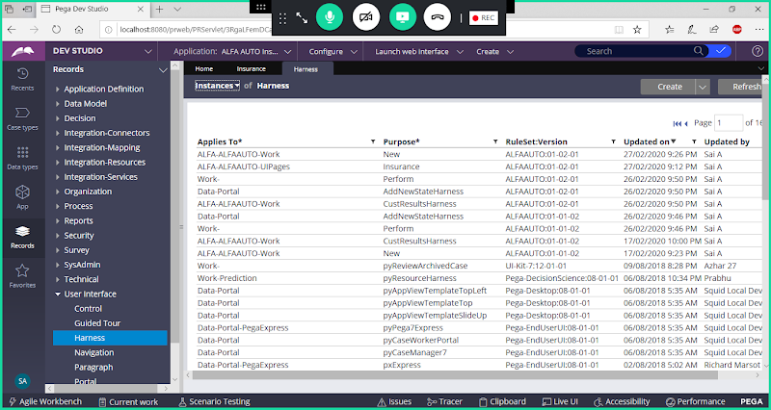

**Open Perform Harnes ( Latest Version Rule)**

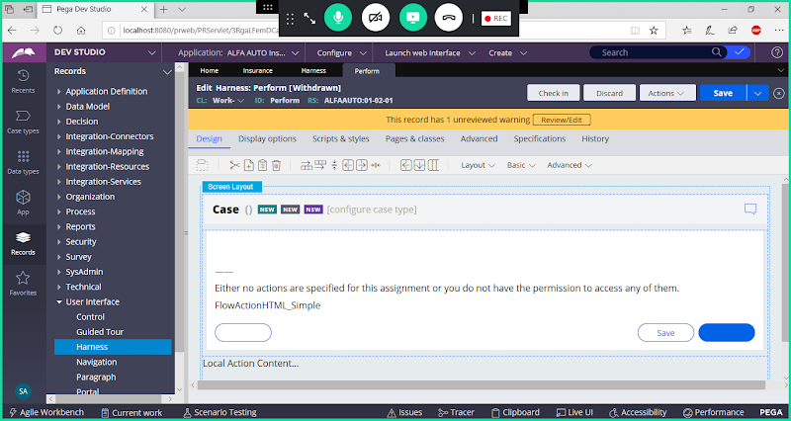

**Save & Check in**

**In Insurance Case Open Each Sub Flow & Add the Flowaction Names ( Replace with User Defined Flowaction which are created in Parent Class)**

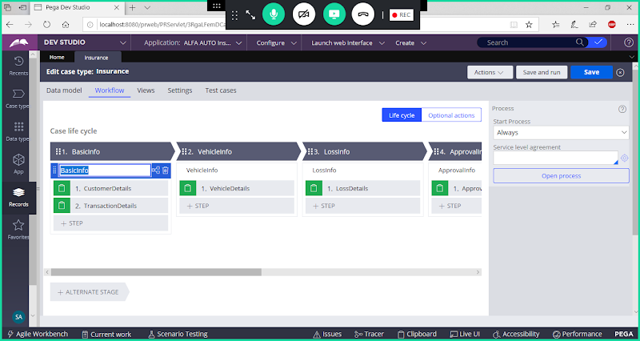

**Open Process & Configure Flowactions**

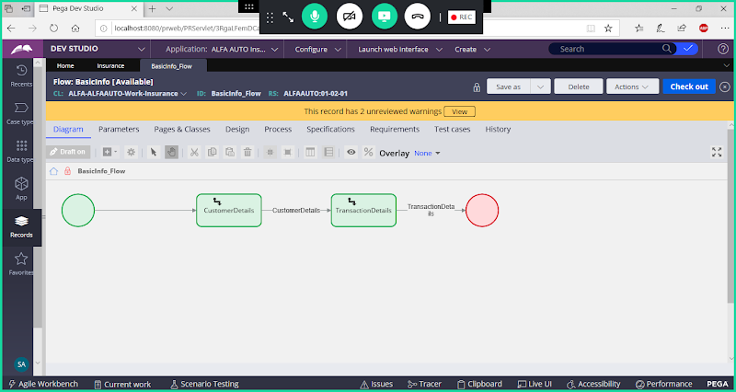

**Open Assignment Connector Properties & Replace Flowaction Names.**

**Save & Check in**

**Similarly configure remaining flow in the case type: ( Open Flow & Update the Flowaction from Work Layer)**

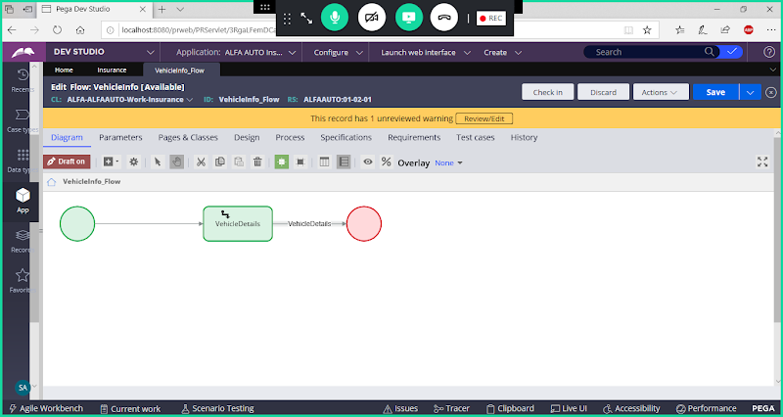

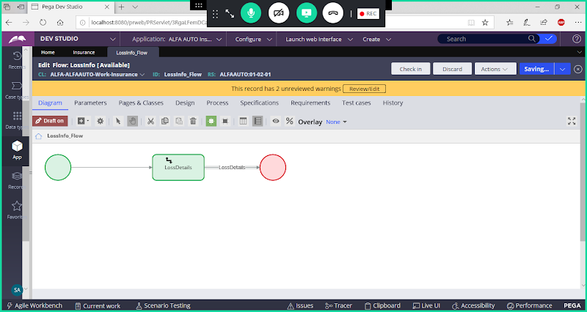

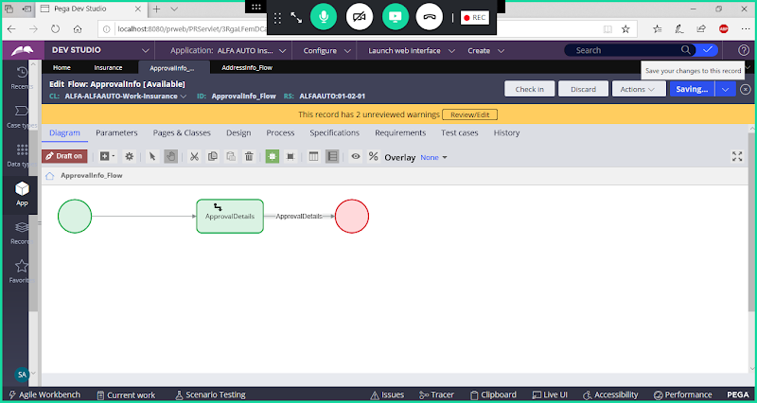

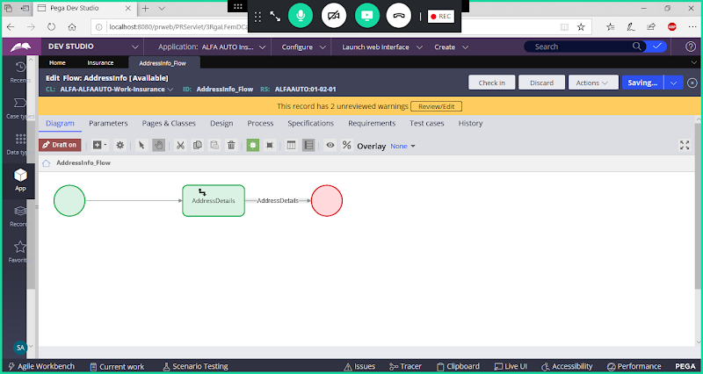

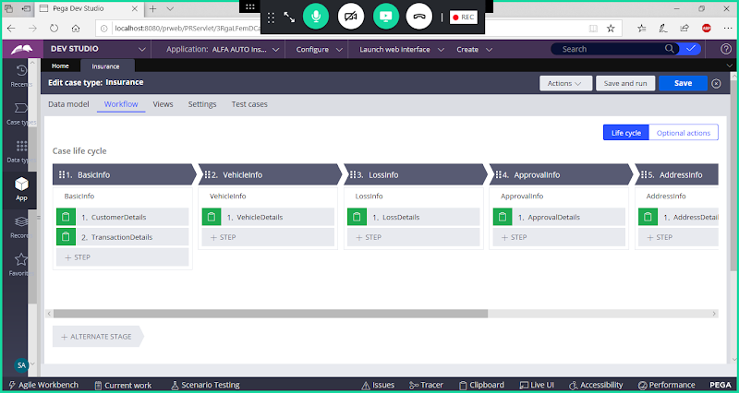

**Save Case & Run the case.**

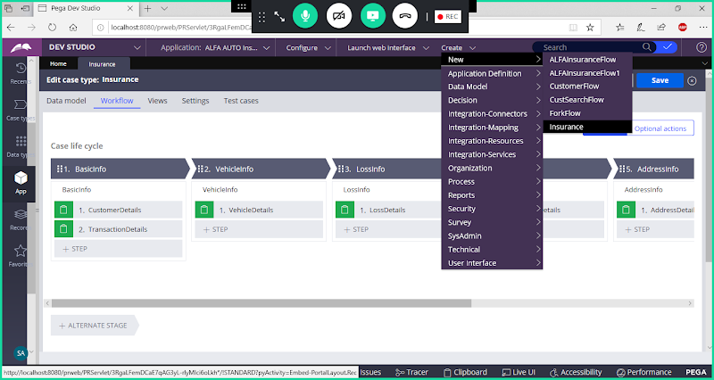

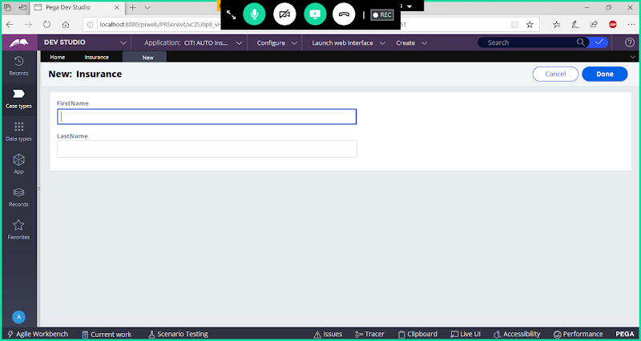

**Click On Done**

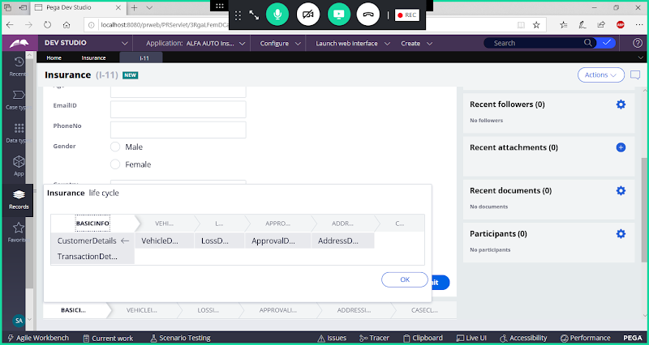

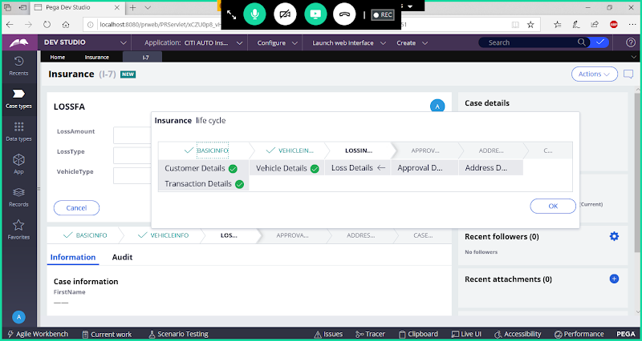

**Adding Change Stage Utility:**

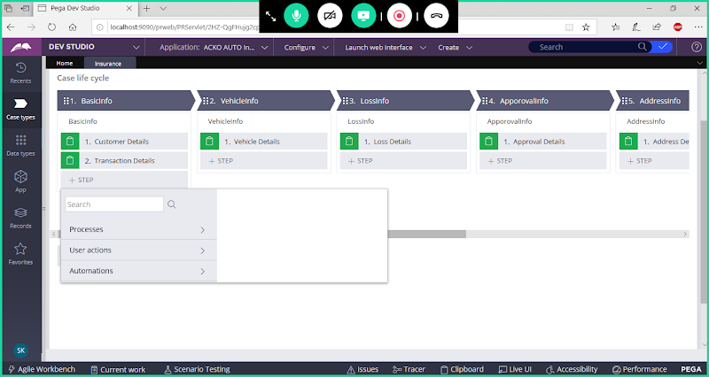

**Click on Automations**

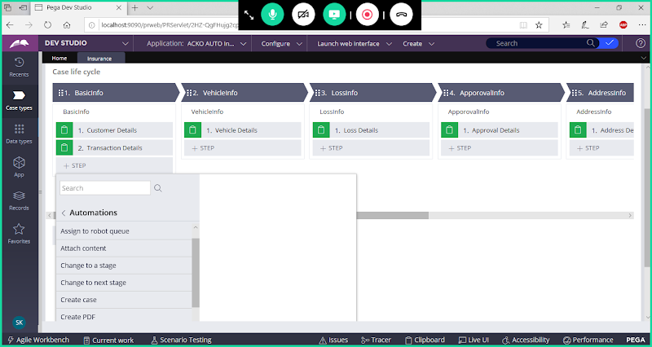

**Select Change to a Stage/ Click on Change Stage:**

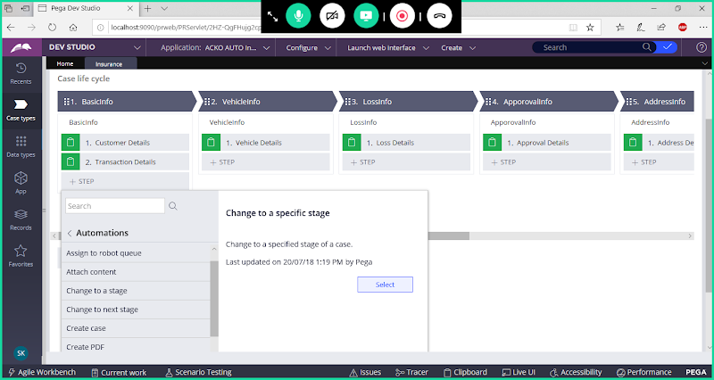

**select**

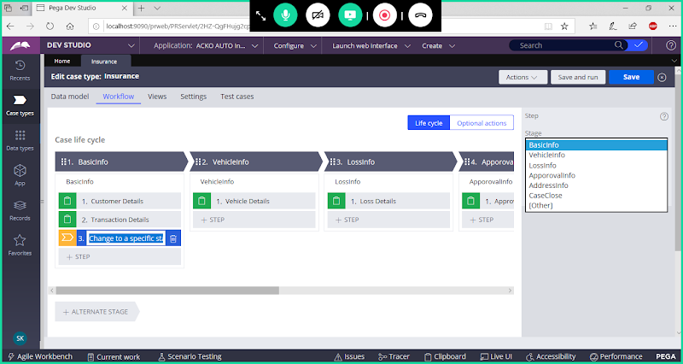

**Select Stage**

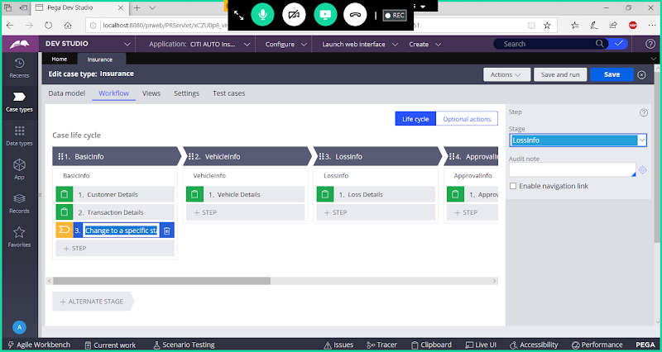

**Save & Run Case:**

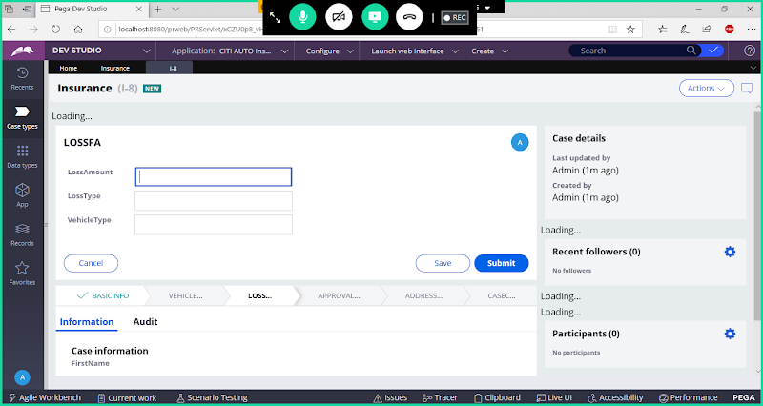

**======**

**Insurance: Main Case Type**

**Add Sub Case Types**

**Case Management:**

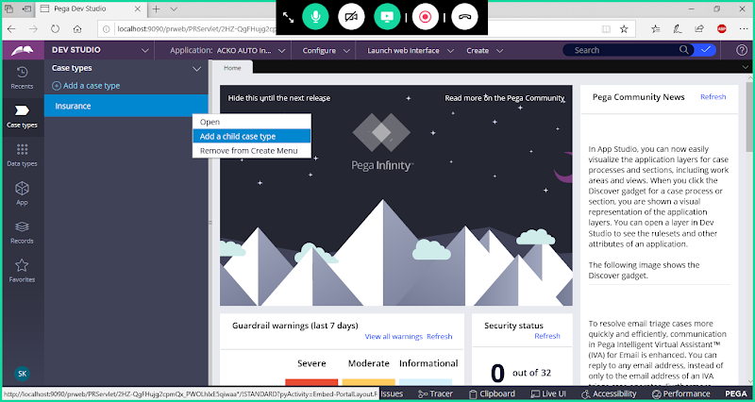

**Add Child Cases : Verification  & Approval**

**Go to Case Types Explorer:**

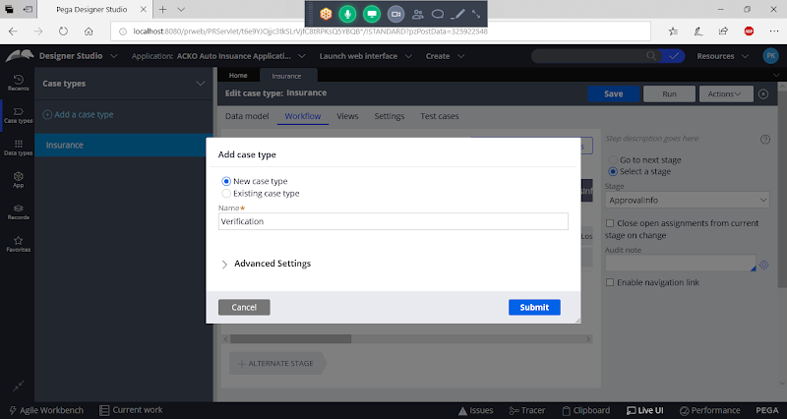

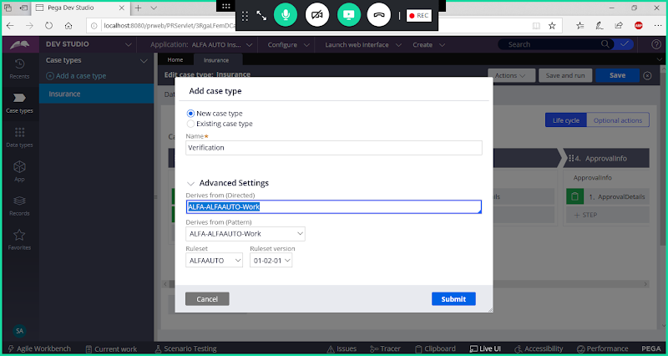

**Change Directed Parent to Insurance Class:**

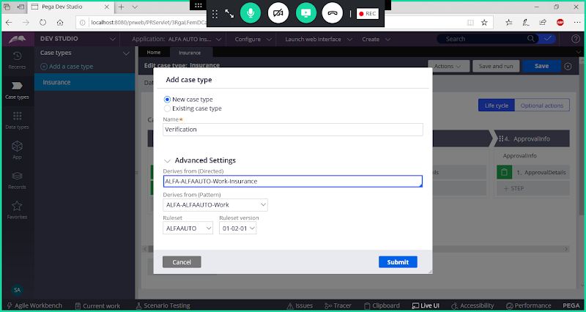

**Submit**

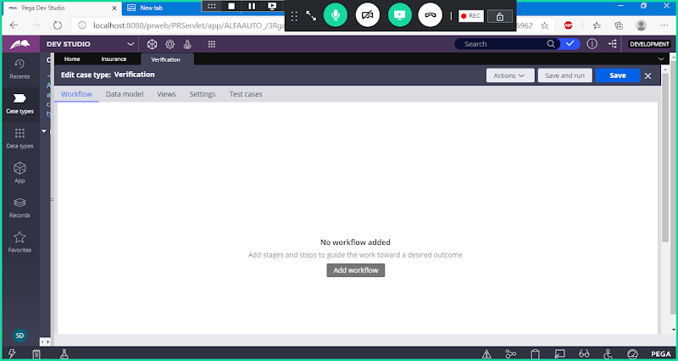

**Go to Data Model**

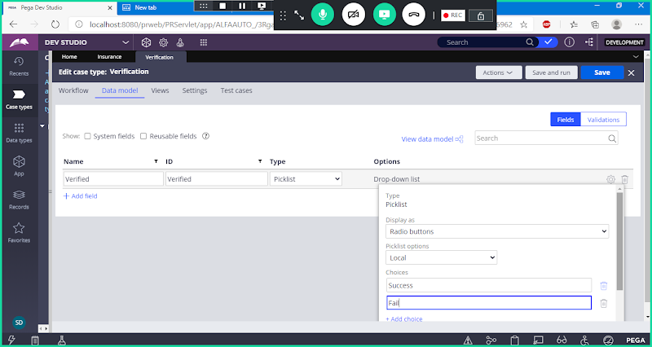

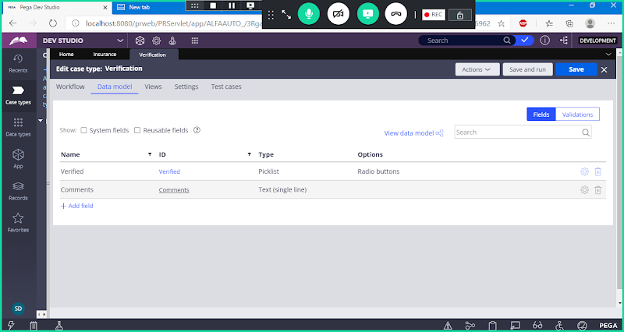

**Go to Work Flow Tab:**

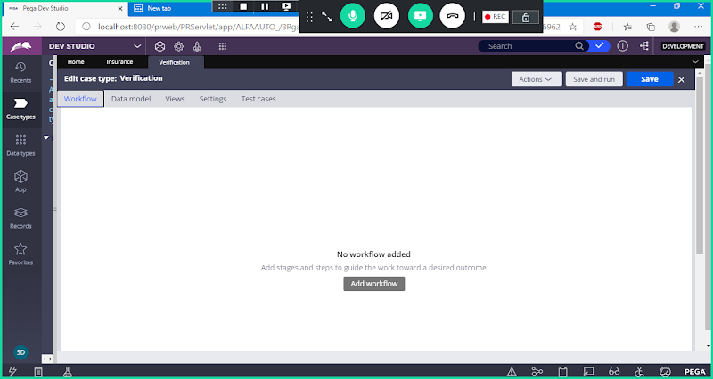

**Click on Add WorkFlow**

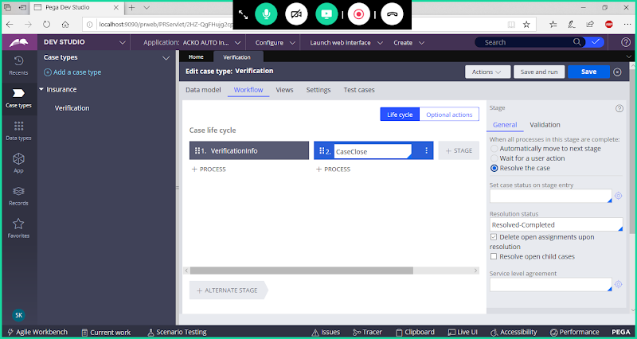

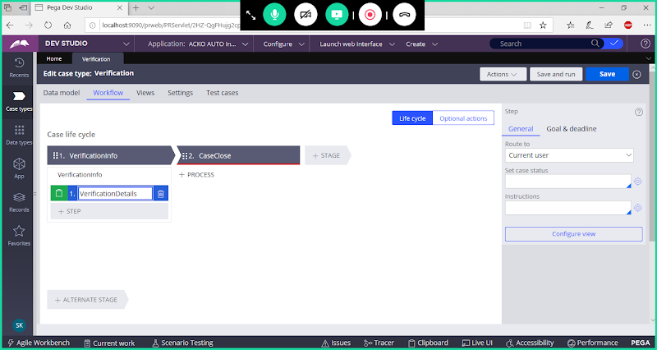

**Configure View**

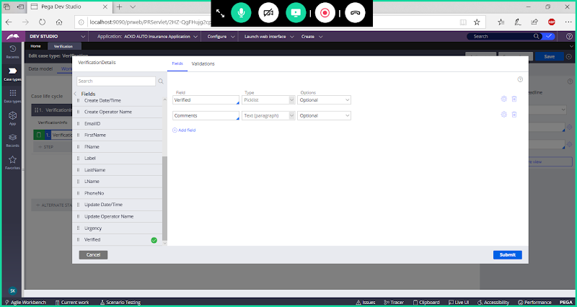

**Submit**

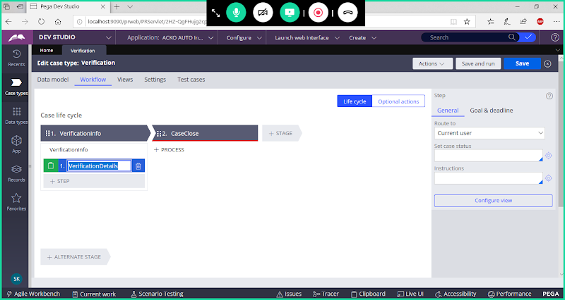

**Save Verification case.**

**Add Child Case: Approvals:**

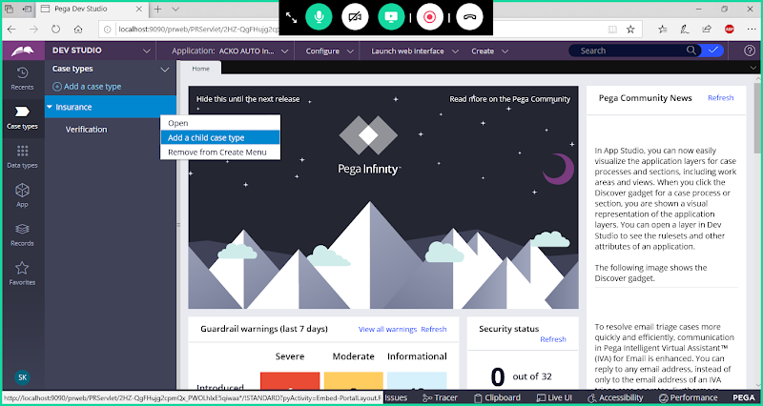

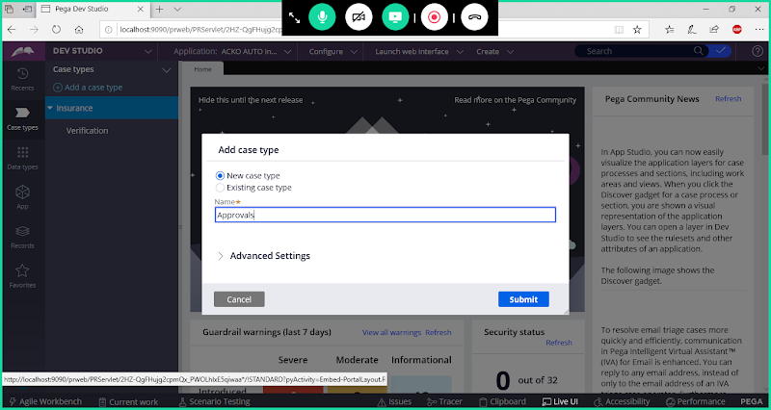

**Change Direct Inheritance:**

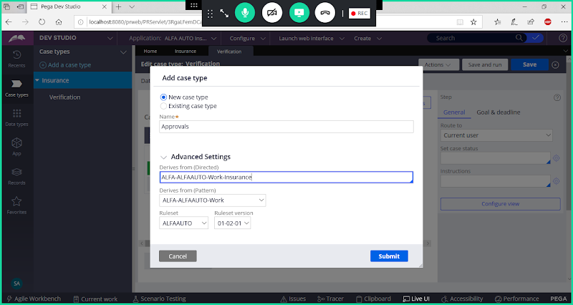

**Submit**

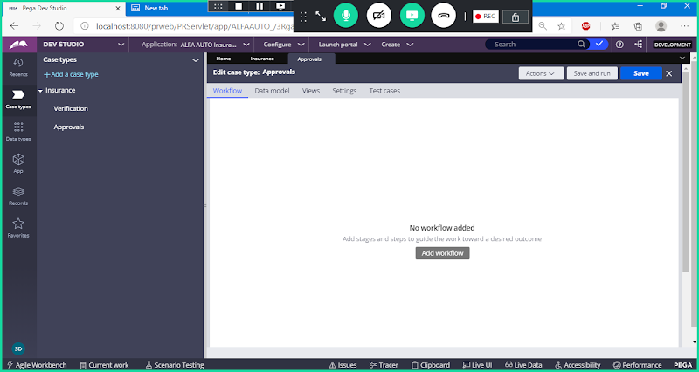

**Go to Data Model**

**Add Fields:**

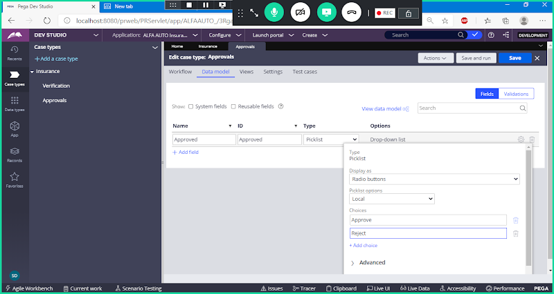

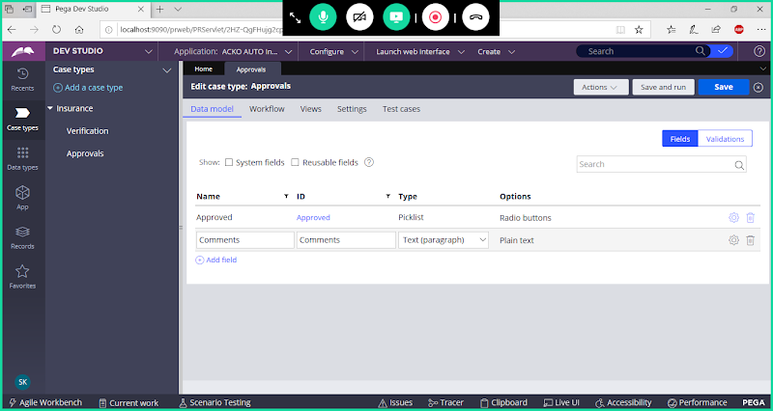

**Go to Work Flow Tab:**

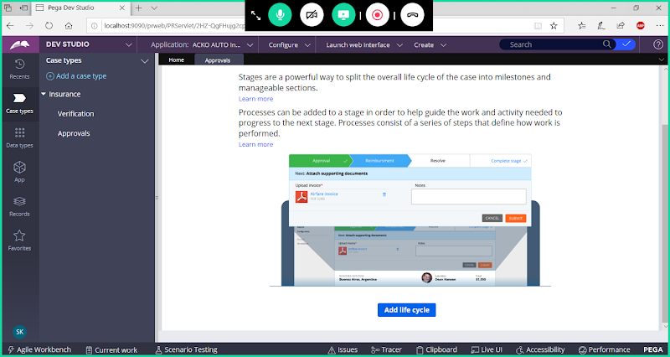

**Add Life Cycle**

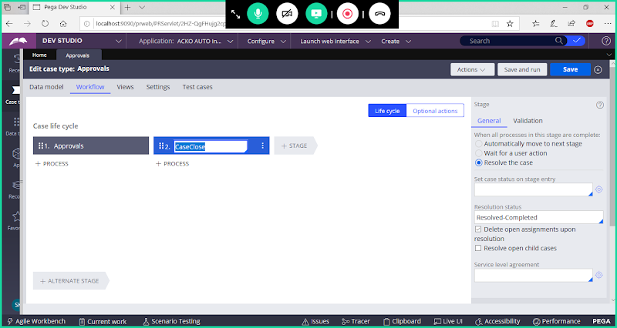

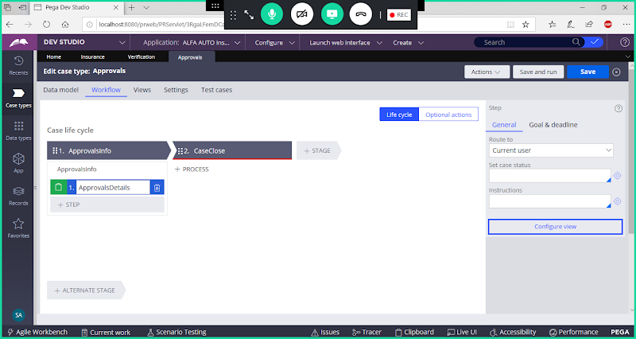

**Configure View**

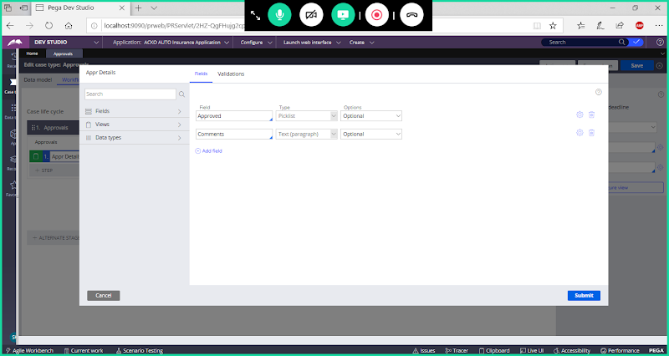

**Submit**

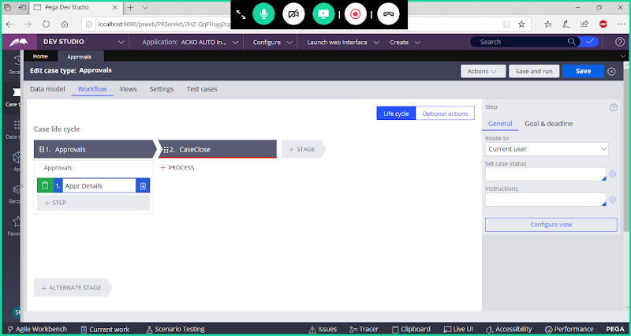

**Save Case**